Team ID: PNT2022TMID13652

# CREATE IBM WATSON IOT PLATFORM AND DEVICE

**AIM:**

To create the IBM Watson IoT platform and device

# STEPS:

1. Firstly create an IBM cloud account with IBMid and password.

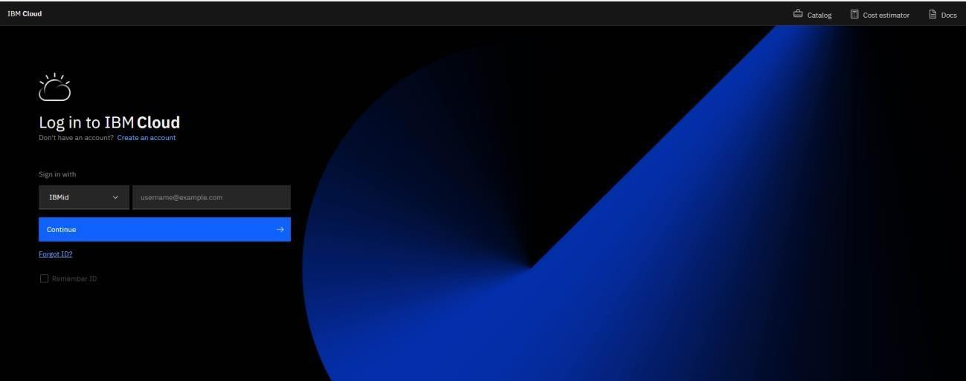

1. Home page of IBM cloud.

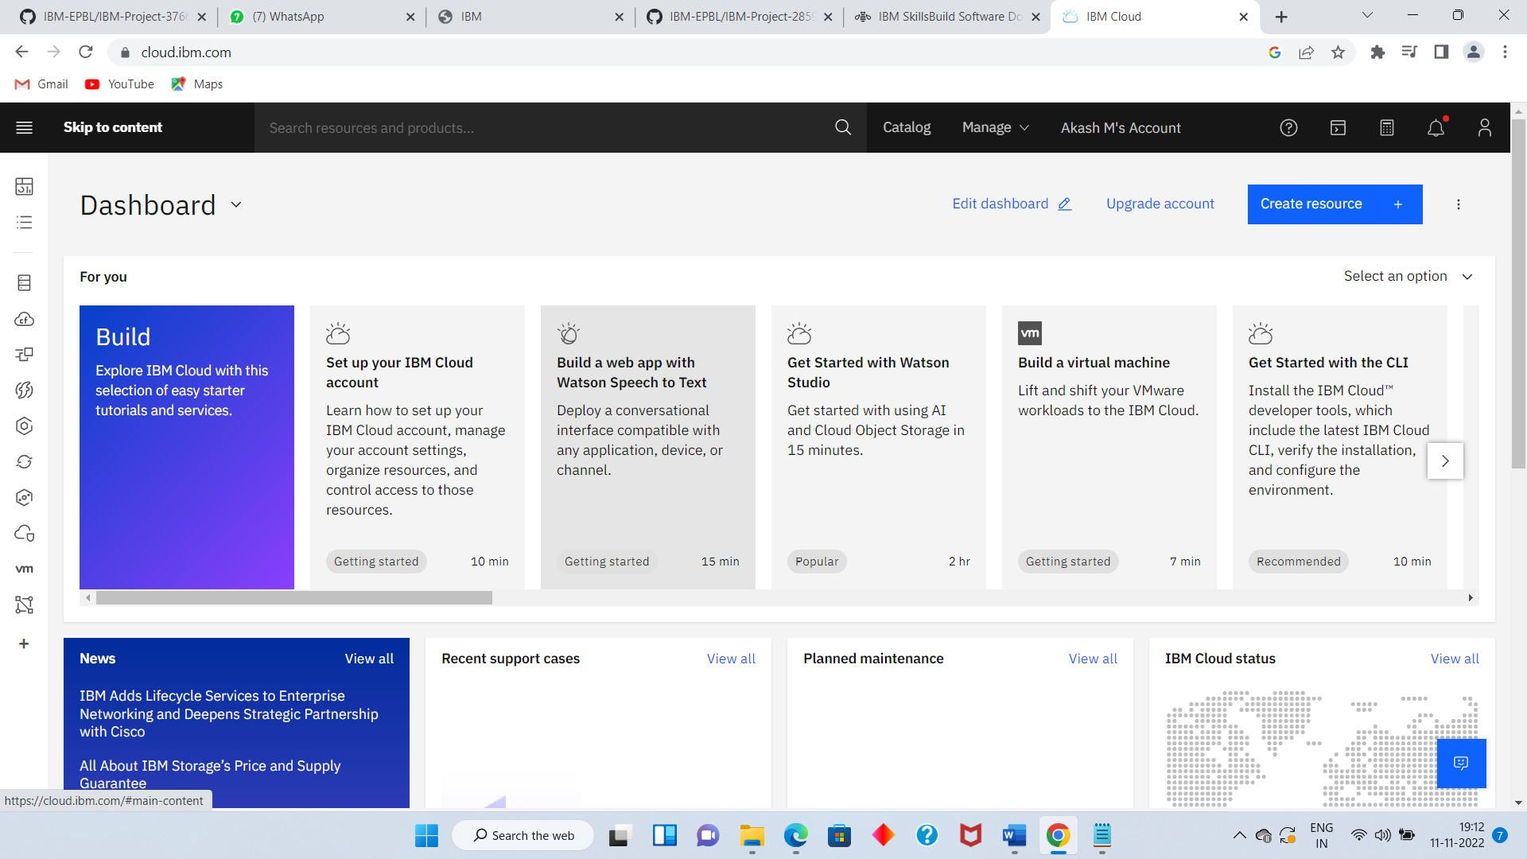

1. Click on the catalog on the top.

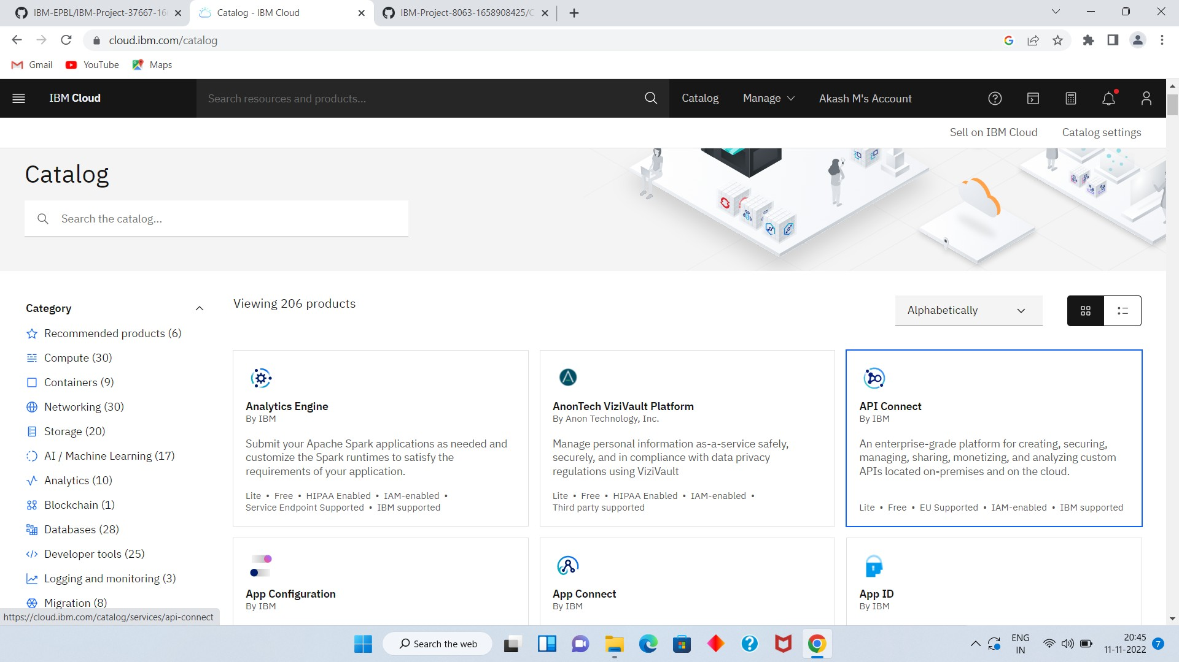

1. 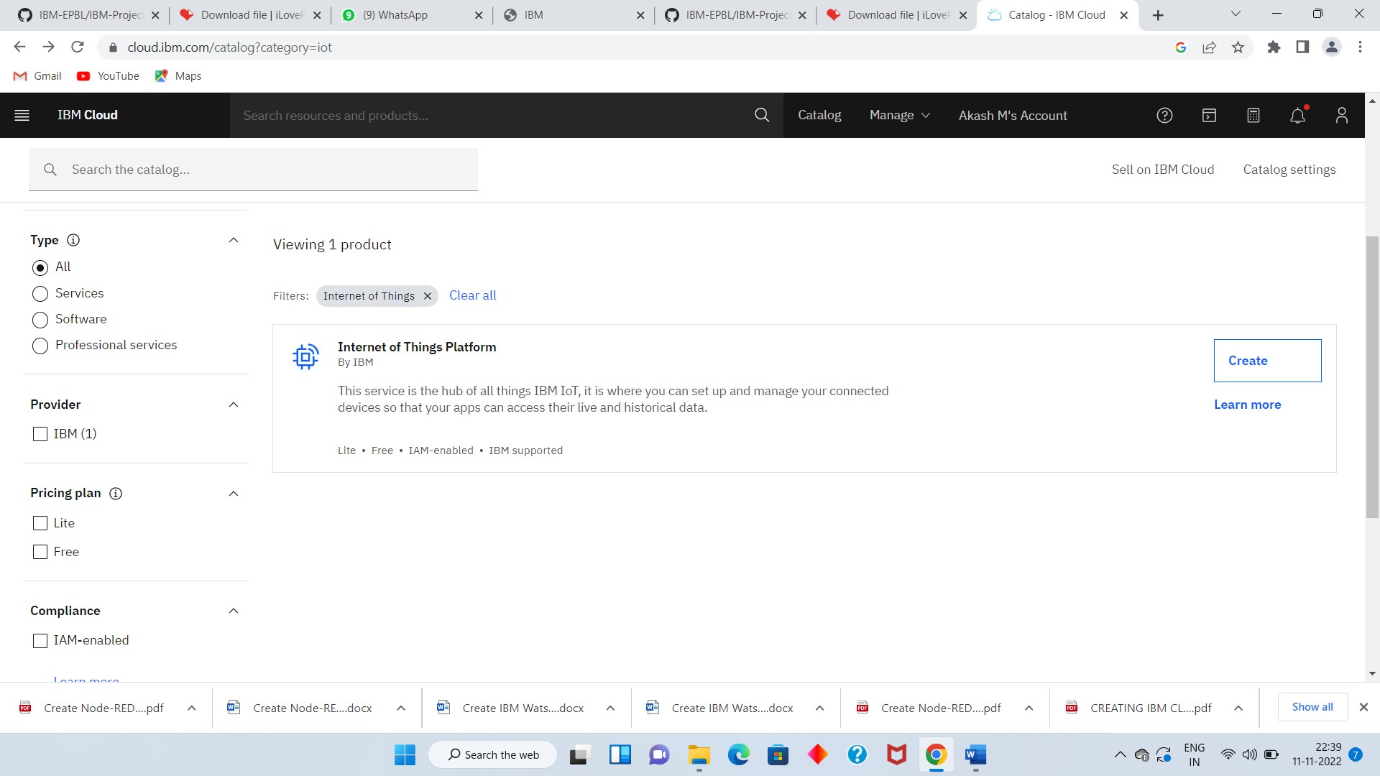Click on IoT in the category mentioned.
2. If already a lite is present delete it else u can’t create another.

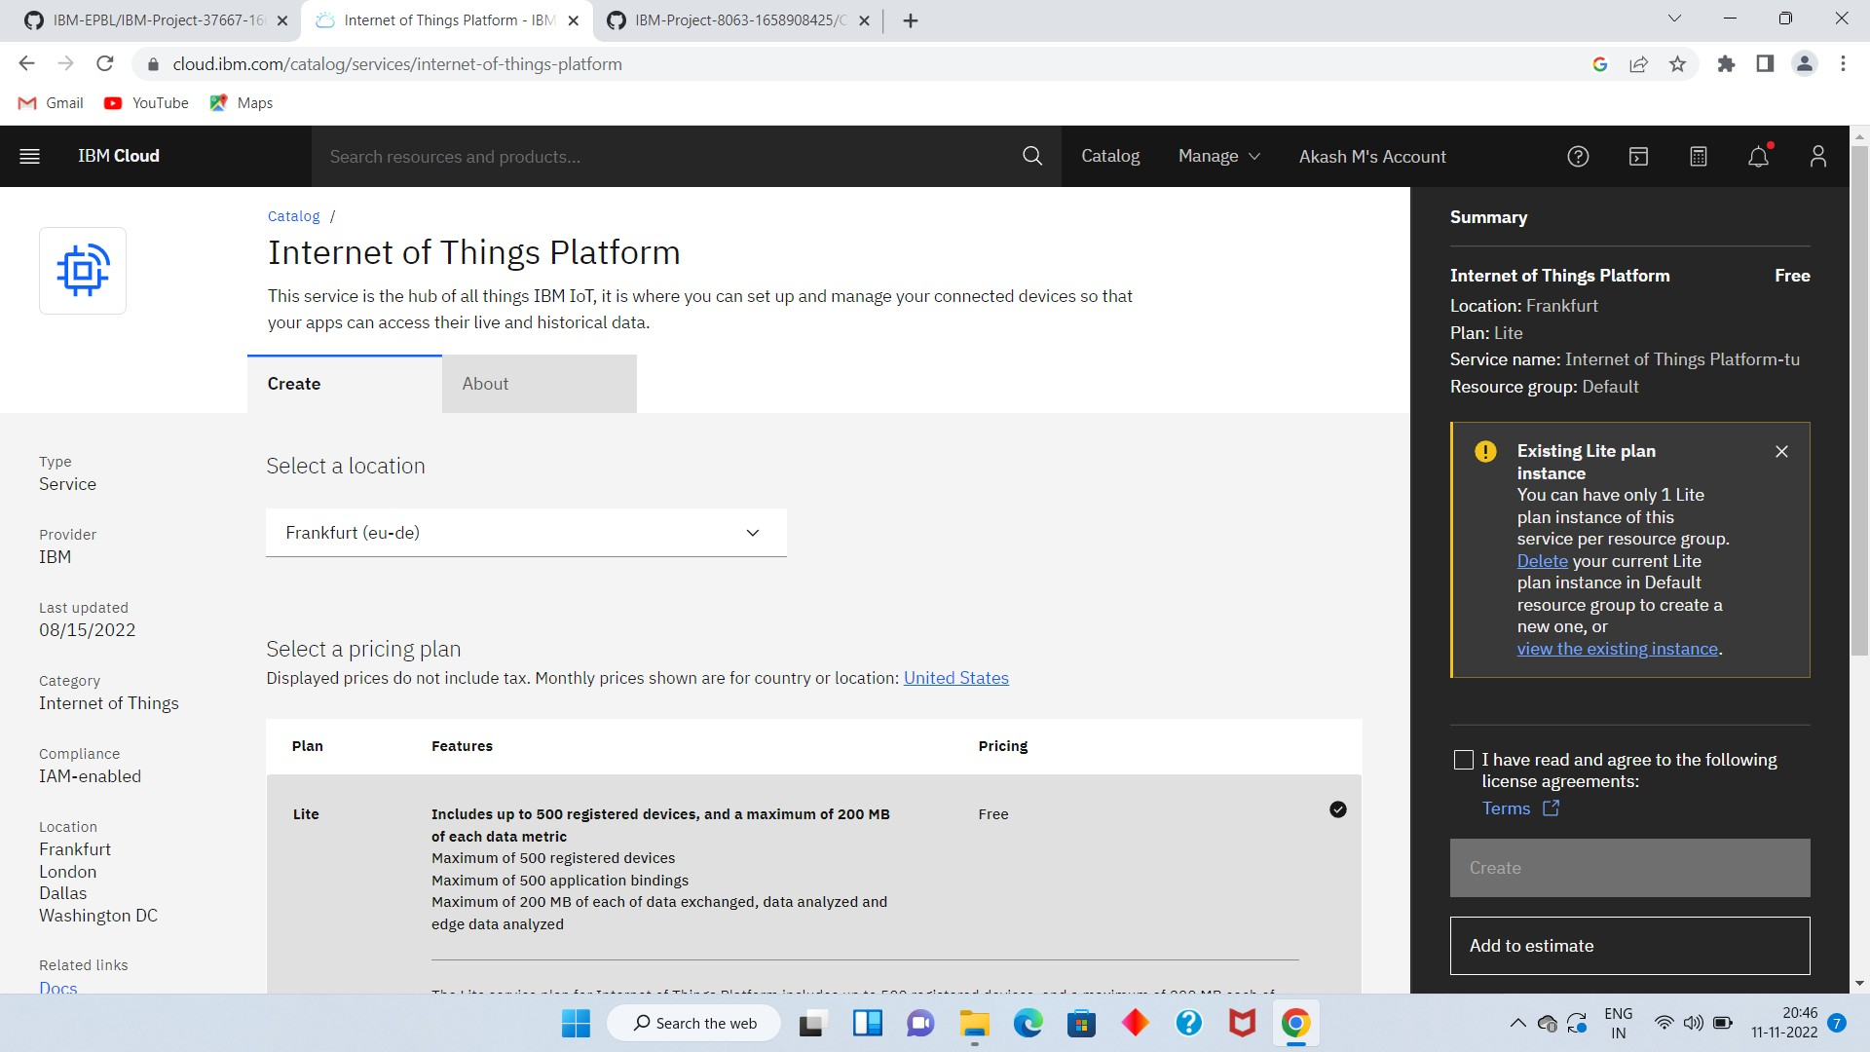

1. Enter the location and in the configure your resource type the service name and choose the plan, tick the agree with agreements and then click on create.

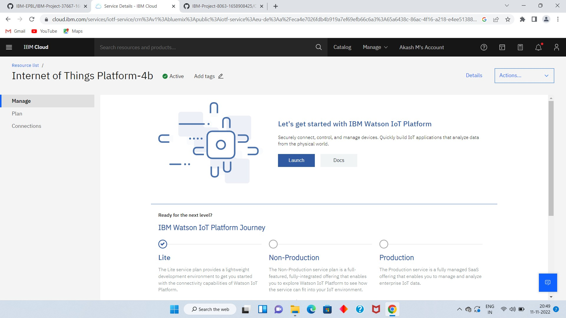

1. Internet of Things Platform Child_safety will be created, where there are different options like manage, plan, and connection ( manage is for launch, Plan gives us the idea about the payment package and its upgrades, and lastly the connection is for to connect IoT with other servies)



1. Clicking on the launch button in the manage tab, it will open to this.

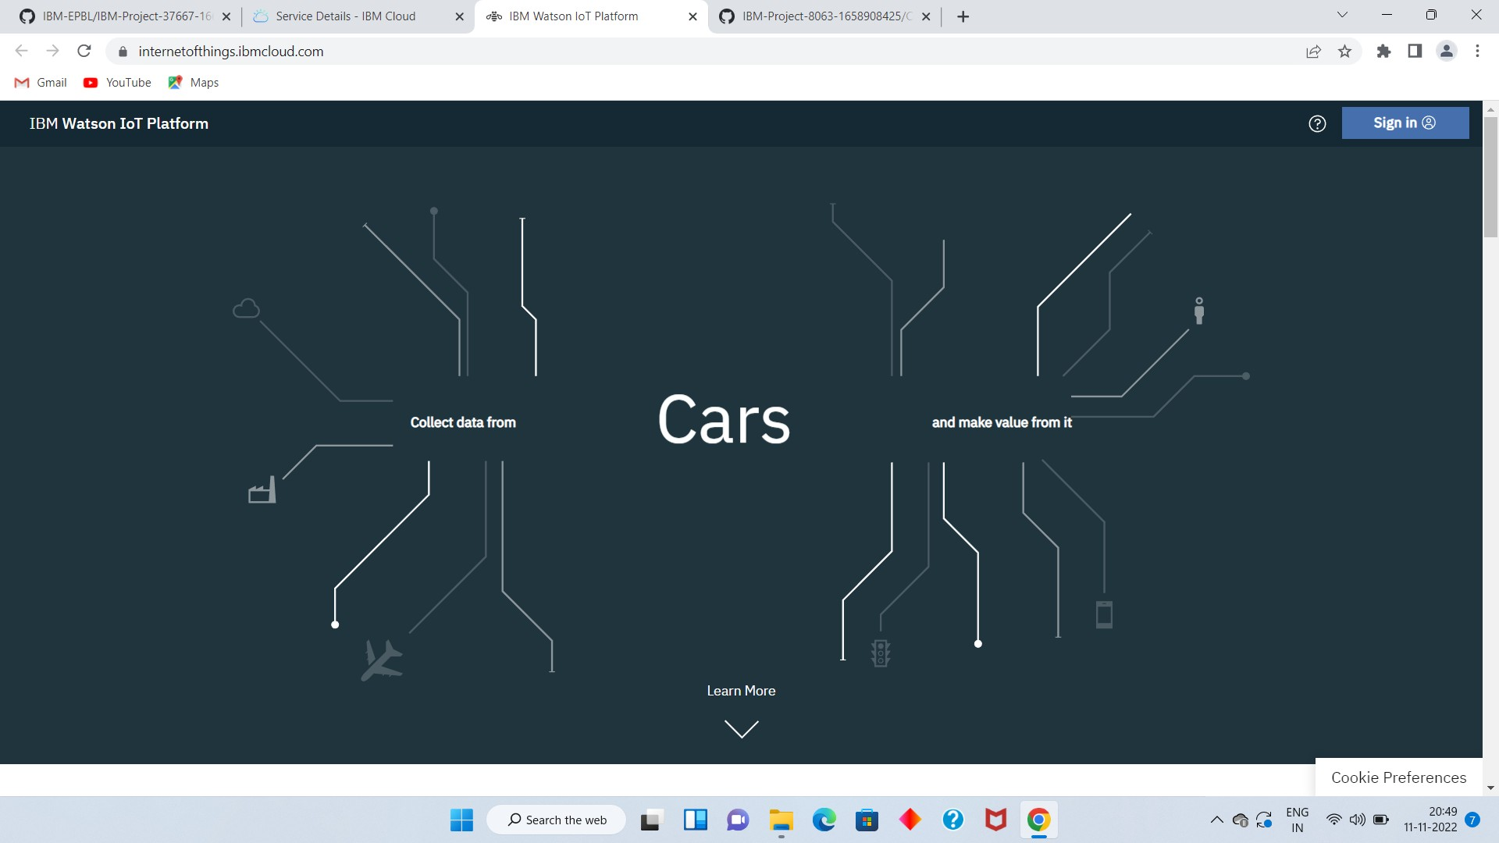

1. Enter the details to sign in to the Watson Cloud to create a device.

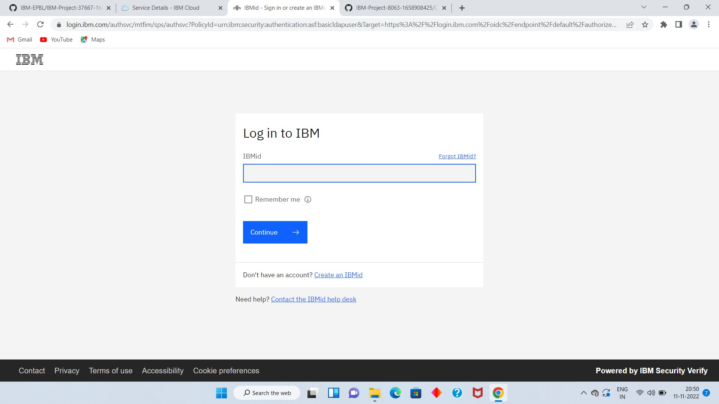

1. Once logged in the name will be displayed and it goes back to the first page.

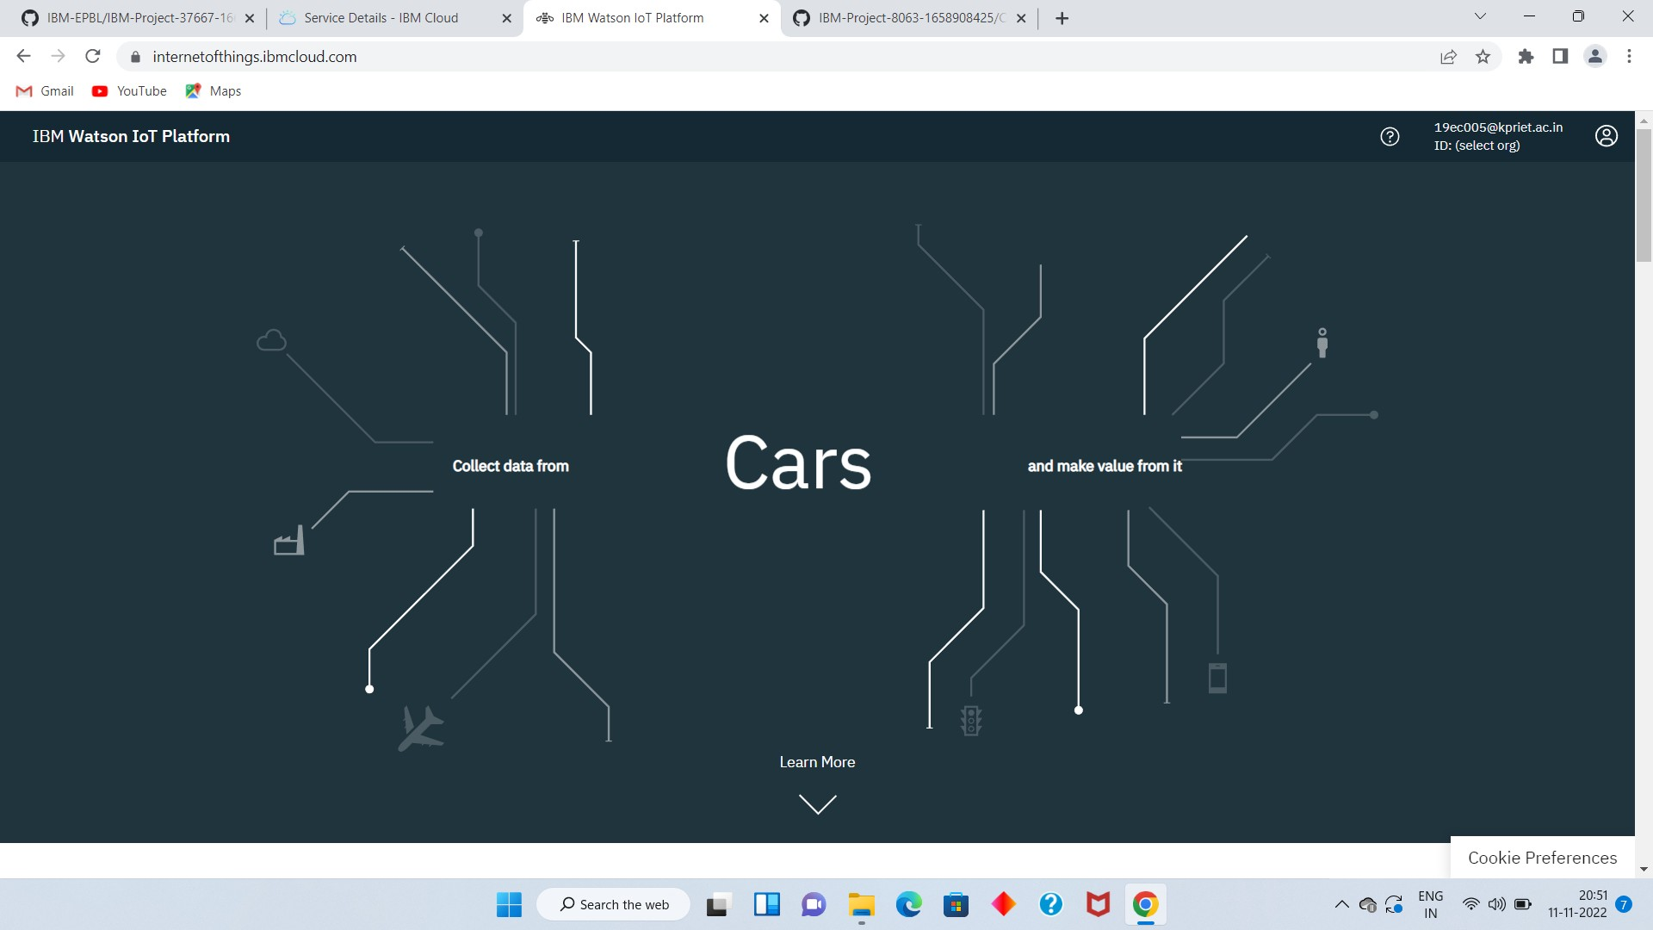

1. And again clicking on the launch button will open this tab, the device will help in the creation of thedevices, the addition of devices, and the display of details of the devices and Click on the device tab and click on the add device button, then give the device type and device idand click next.

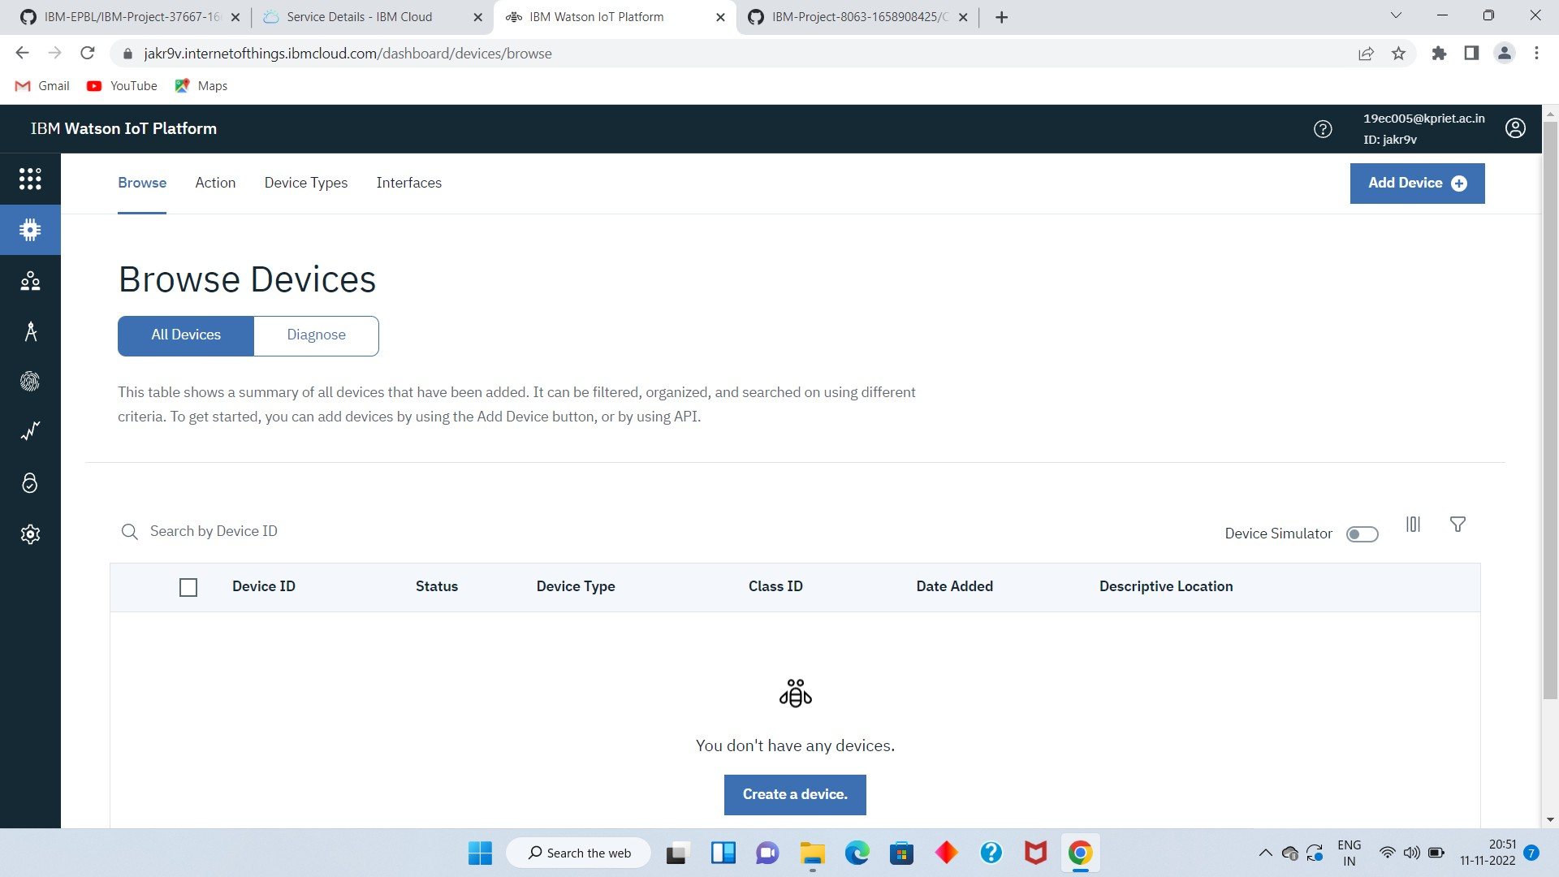

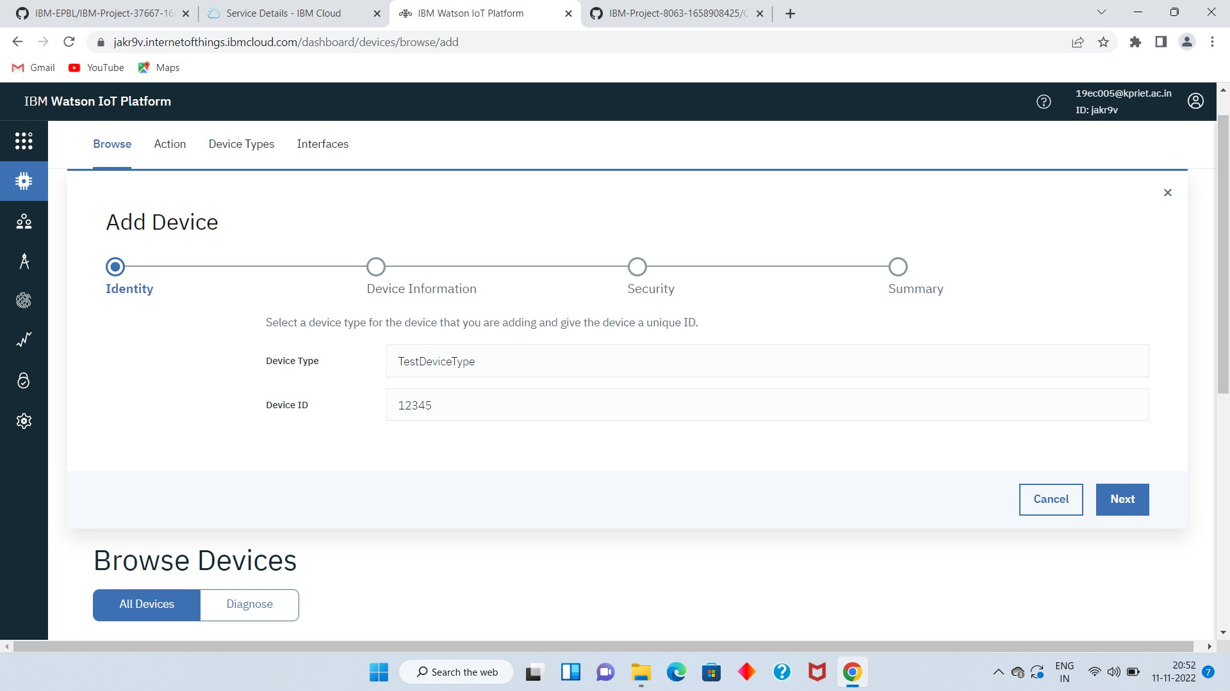

1. This page to enter extra details and of the hardware.

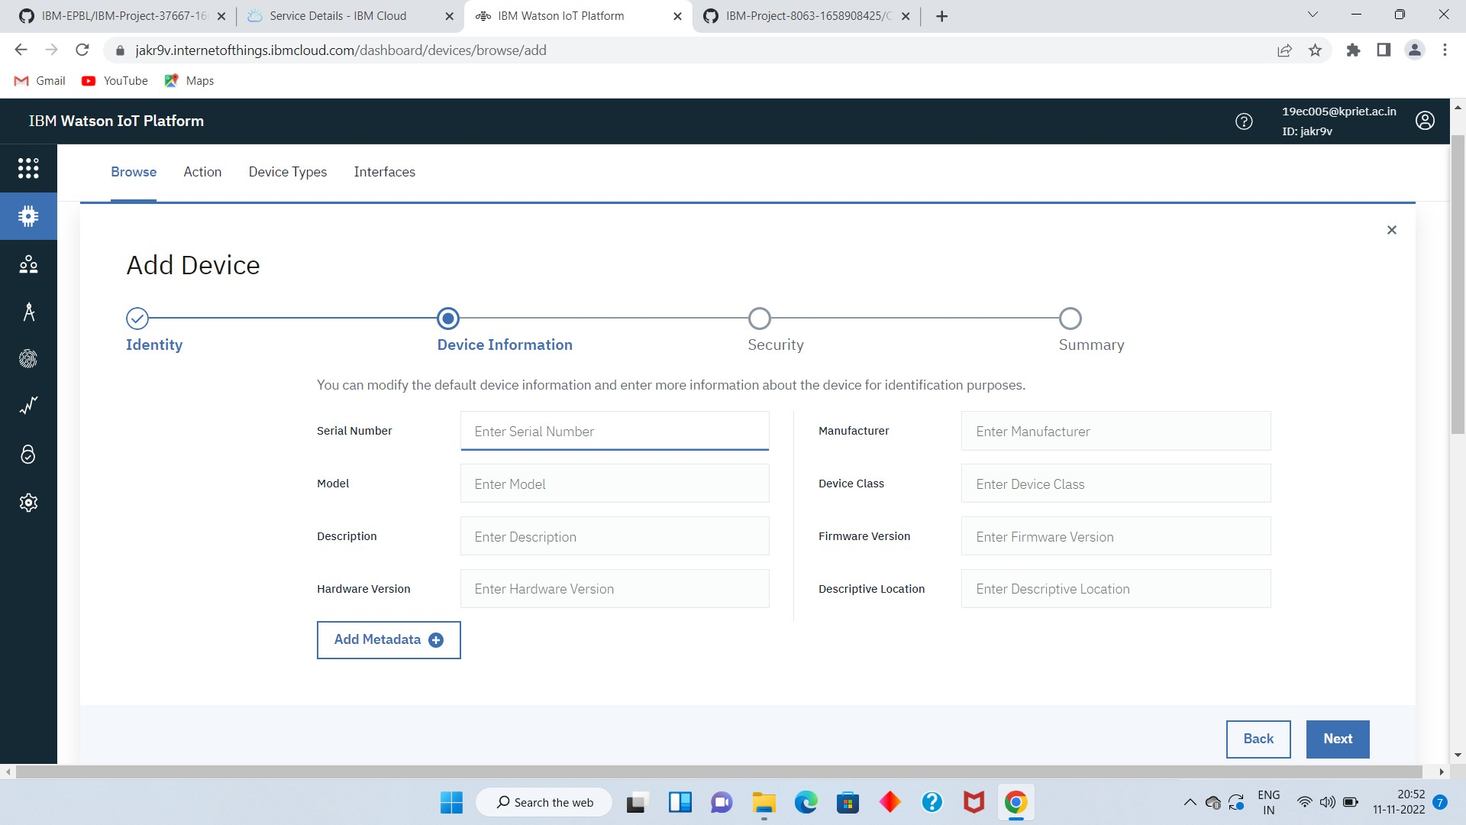

1. Clicking next it goes to the security where we do authentication token id.

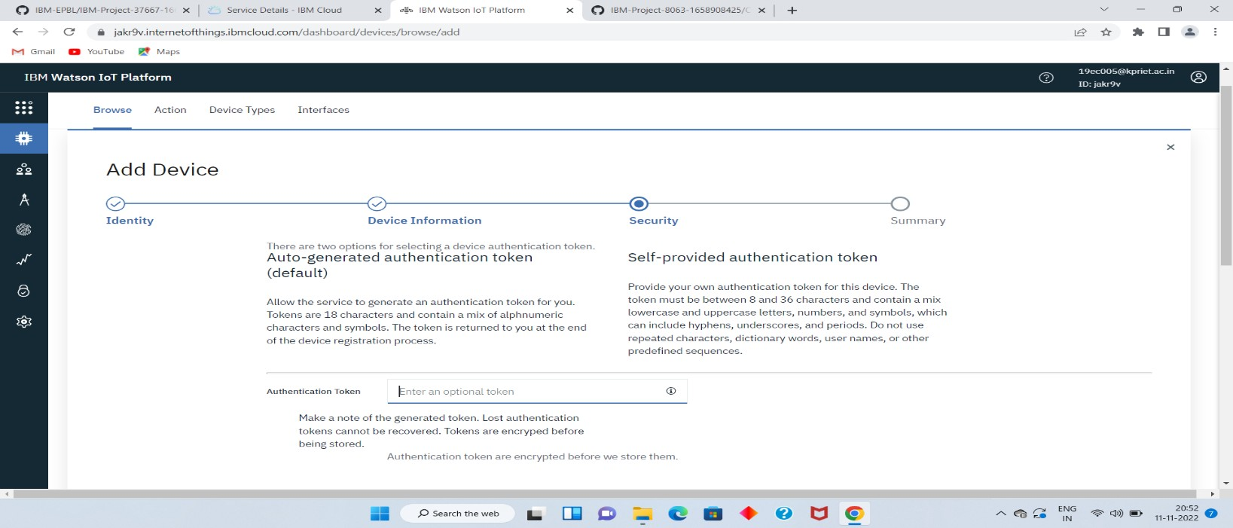

1. Clicking on next it goes to the summary of the device then click finish.

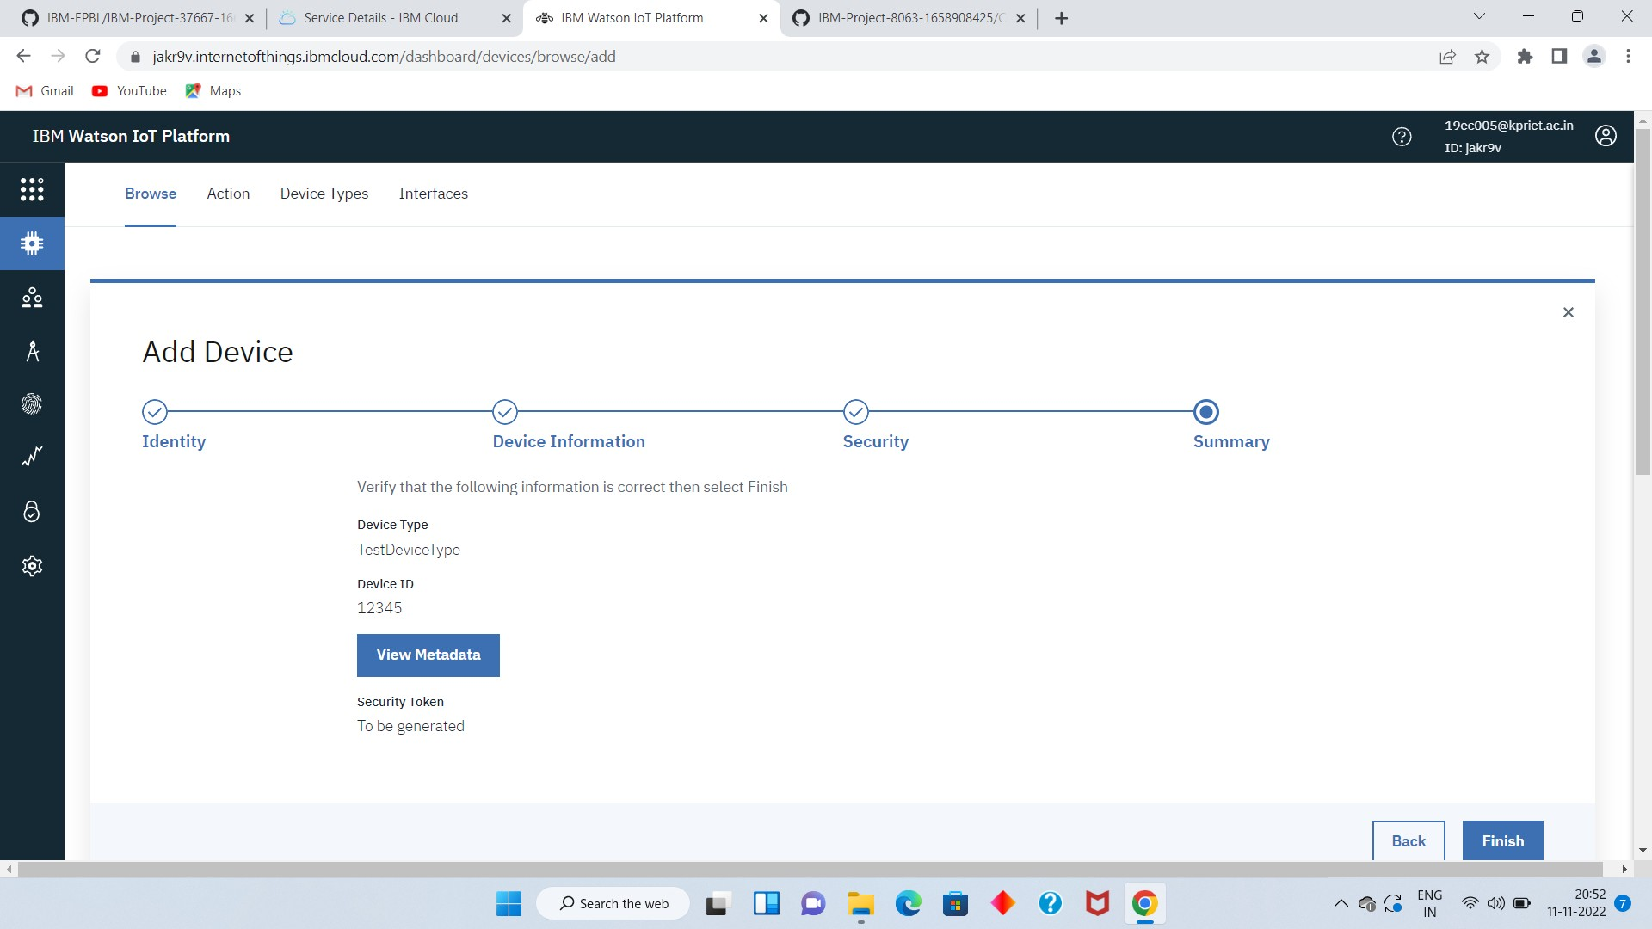

1. Clicking on the device tab we can now see the added device. Clicking on it will display the otherdetails. It has different tabs like Identity, Device Information, State and login

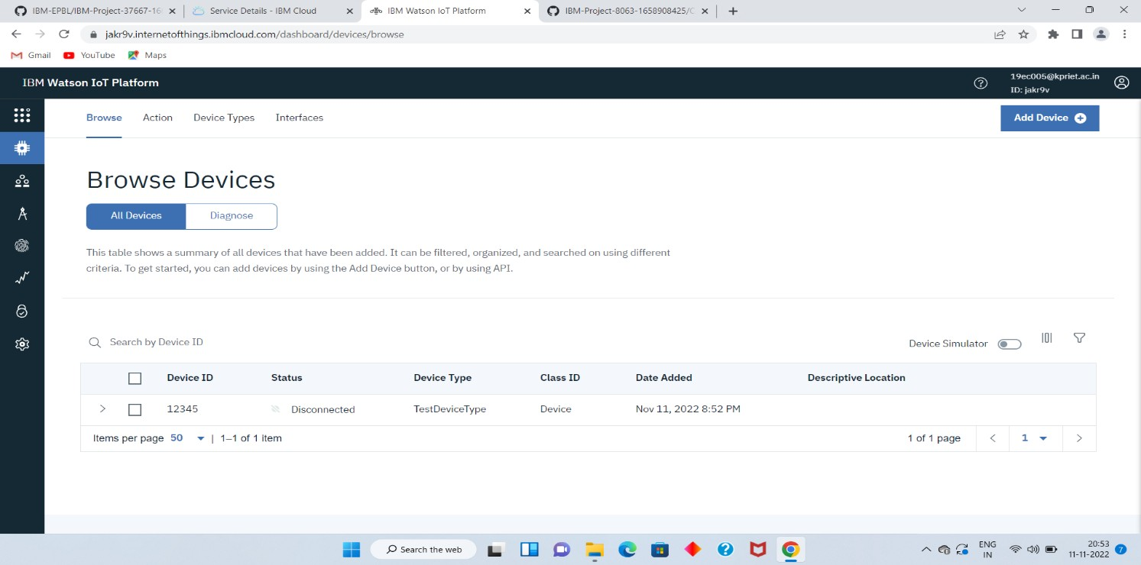

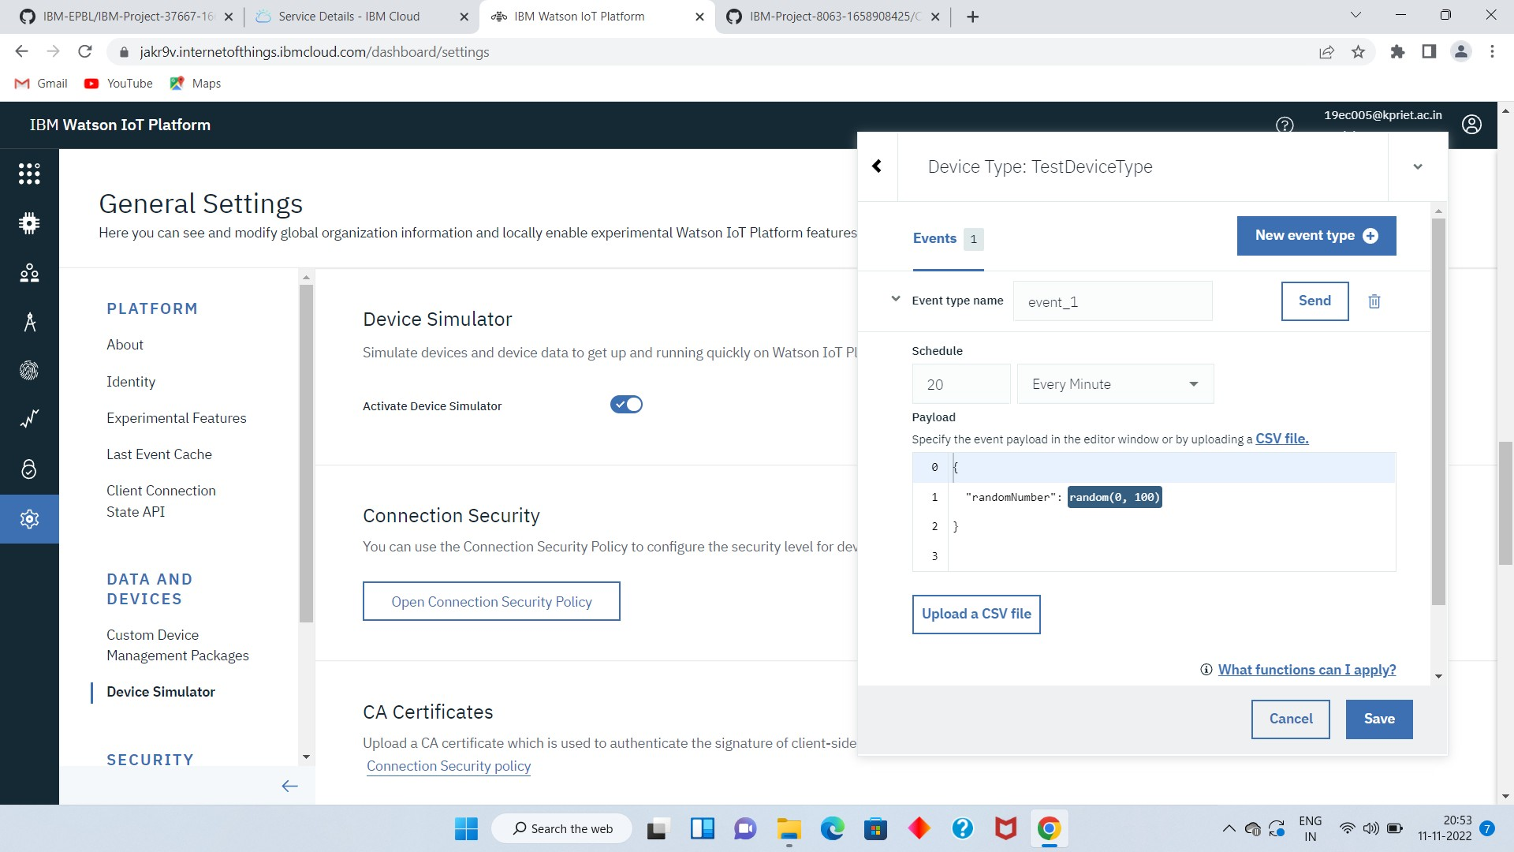In a similar way, we can create n number of devices with a 50 per page limit as per the requirement ofour project.

1. The Boards will display card for the project.

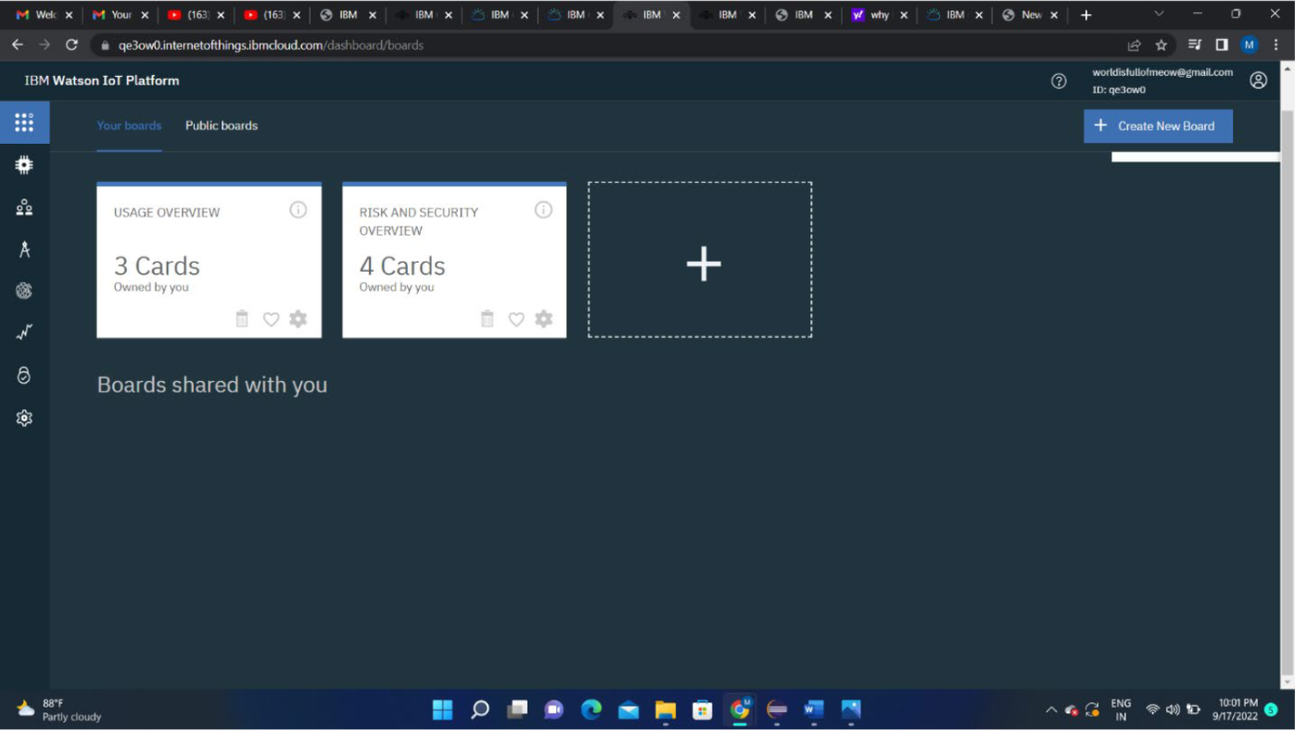

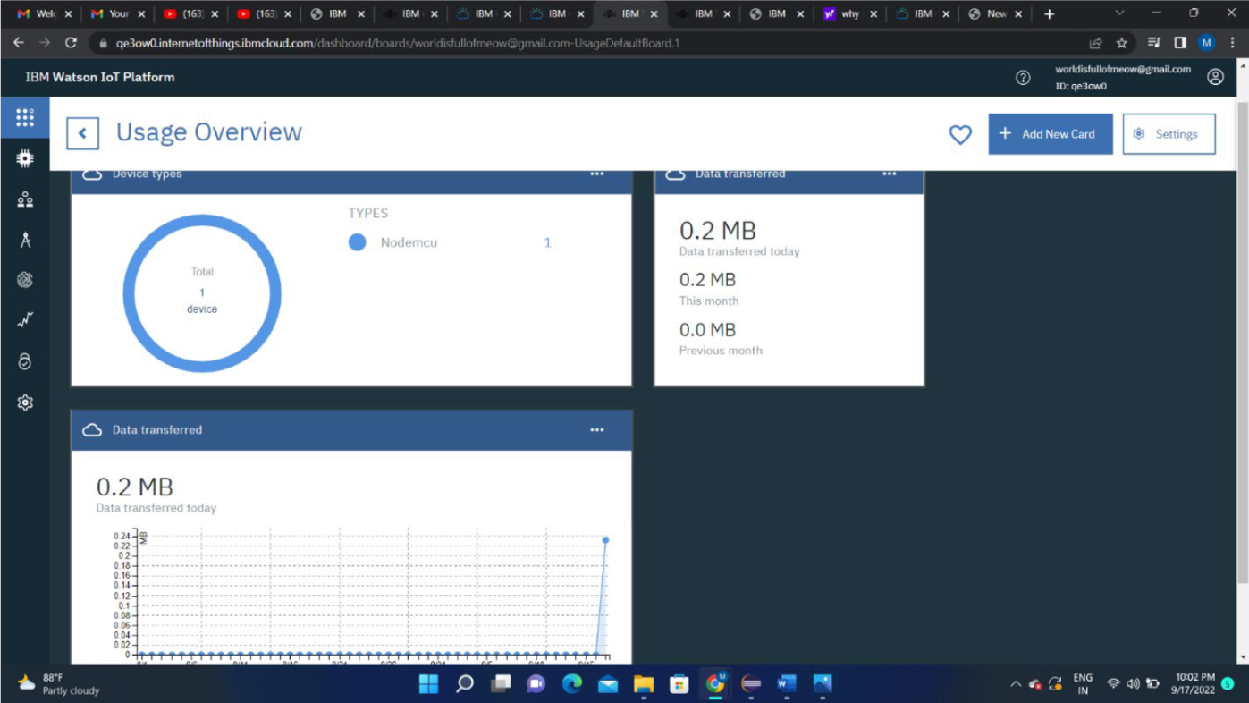

# RESULT:

An IBM Watson cloud for IoT and a device is create